AI ASSITED CODING
LAB-15.4
NAME:V.SAI LASYA REDDY
BATCH-4
ROLLNO:2403A52082
TASK-1:
PROMPT: Generate Python code to set up a basic Flask backend with one endpoint. The endpoint should be `/` and return a JSON response: {"message": "Welcome to AI-assisted API"}. The server should run locally on port 5000 with debug mode enabled.
CODE:
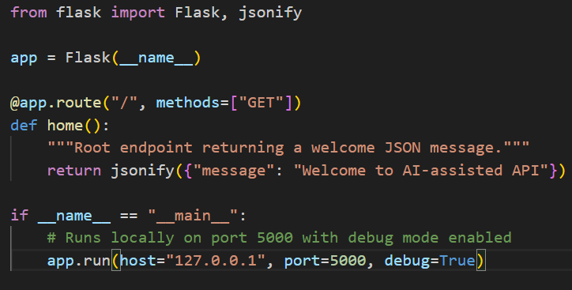
OUTPUT:
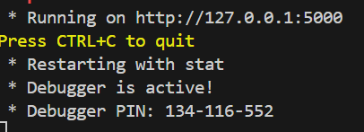
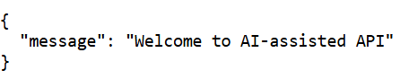
- OBSERVATION: Defines a minimal Flask app with GET / returning {"message":"Welcome to AI-assisted API"}.Runs locally on 127.0.0.1:5000 with debug=True.Requires Flask (pip install flask).Note: disable debug in production and change host to 0.0.0.0 to expose externally.
TASK-2:
PROMPT: Create a Flask backend with two endpoints:
1. GET /items → returns a JSON list of items (initially empty).
2. POST /items → accepts JSON payload like {"name":"Book","price":200}, adds it to the list, and returns {"message": "Item added", "item": {...}} with status code 201.Use `request.get_json()` to parse incoming data and `jsonify()` for responses. Include a global `items` list to store data in memory. Enable debug mode and run on localhost.
CODE:
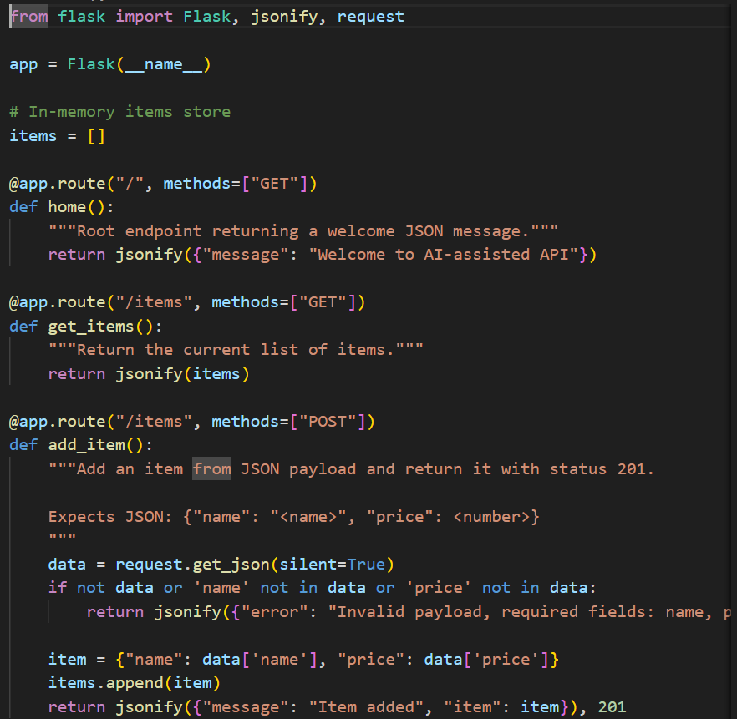
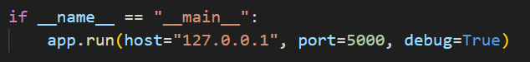
OUTPUT:
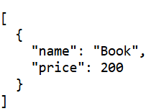
OBSERVATION: Simple Flask app with three endpoints: GET /, GET /items, POST /items.Uses an in-memory list items (no persistence across restarts).POST validates presence of "name" and "price" but does not enforce types or sanitization.No update/delete endpoints (PUT/DELETE) and no item IDs — only append-by-order.Runs in debug mode on 127.0.0.1:5000 (development only).No CORS handling or authentication (calls from other origins may fail).Consider adding input type checks, error messages, persistence, and PUT/DELETE or id fields for full CRUD.

